**A**

**TECHNICAL SEMINAR REPORT ON**

**SMART NOTE TAKER**

### Bachelor of Technology In

**COMPUTER SCIENCE AND ENGINEERING**

### Submitted by

## M. NAVITHA– 19RJ1A05D4

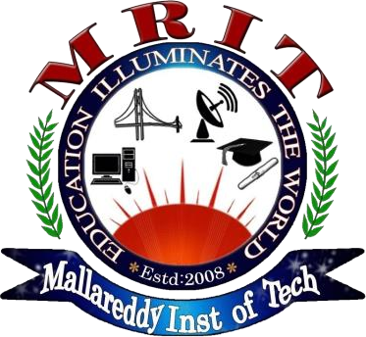

MALLA REDDY INSTITUTE OF TECHNOLOGY

## (Affiliated to JNTU, Hyderabad | Approved by AICTE, New Delhi) Accredited by NBA, Certificated by ISO 9001:2015 Maisammaguda, Dhulapally, Via: Kompally, Hyderabad - 500100 2019 - 2023

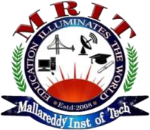**MALLA REDDY INSTITUTE OF TECHNOLOGY**

## (Sponsored by Malla Reddy Educational Society) Accredited by NBA, Certificated by ISO 9001:2015 Approved by AICTE & Affiliated to JNTU, Hyderabad

Maisammaguda, Dhulapally Post, (Via: Kompally), Secunderabad - 500100.

**CERTIFICATE**

This is to certify that Technical Seminar Report entitled **“SMART NOTE TAKER”** is a bonafide work carried by **M.NAVITHA, (19RJ1A05D4),** of **COMPUTER SCIENCE AND ENGINEERING DEPARTMENT** in **MALLA REDDY INSTITUTE OF TECHNOLOGY**

and submitted to **JNTU, Hyderabad** in the partial fulfillment of the requirement for the award of

## BACHELOR OF TECHNOLOGY.

## Coordinator Head of Department

**Dr. SATEESH NAGAVARAPU Dr.KRN KIRAN KUMAR**

**ABSTRACT**

In today’s technologic and fast life SMART NOTE TAKER is the technology that satisfies the needs of people who want to take fast and easy notes. The SMART NOTE TAKER provides facility to people who want to make notes quickly. It can be used in many ways. This technology provides the people a facility of writing notes in air while being busy in their work. The written notes are stored in the memory chip of pen and will be able to read in digital medium after job has been done. This reduces the time and facilitates life. Apart from this it is also proved to be very useful for blinds that think and write freely.

It is also very useful in telephonic conversations between two people where there is need of note taking sometimes. It's also useful especially for instructors in presentations. The instructors may not want to present the lecture in front of the board. The drawn figure can be processed and directly sent to the server computer in the room. The server computer then can broadcast the drawn shape through network to all of the computers which are present in the room. Through this way, the lectures are aimed to be more efficient and fun. This product will be simple but powerful. There will be an additional feature of the product which will monitor the notes, which were taken before, on the application program used in the computer. This application program can be a word document or an image file. Then, the sensed figures that were drawn onto the air will be recognized and by the help of the software program we will write, the desired character will be printed in the word document. If the application program is a paint related program, then the most similar shape will be chosen by the program and then will be printed on the screen.

Since, JAVA Applet is suitable for both the drawings and strings, all these applications can be put together by developing a single Java Program. The JAVA code t hat we will develop will also be installed on the pen so that the processor inside the pen will type and draw the desired shape or text on the display panel.

The server computer then can broadcast the drawn shape through network to all of the computers which are present in the room. By this way, the lectures are aimed to be more efficient and fun. This product will be simple but powerful.

In order to meet the technical requirements of the product we need Operating System Like Windows or Linux in order to implement software part of the project, Displacement Sensors to recognize the displacement of the pen in three dimensions, parallel cable to communicate with computer, software to solve the displacement data and finds the individual coordinate displacements in three axes and transform the data into text format, analog to digital converter to process analog displacement data and convert them into digital format, switch to control the pen and Rechargeable battery.

**CONTENTS**

**Name of Topic Page No.**

1. Introduction 1
2. Historical overview 4
3. System overview 7
4. Techniques used in SNT 11
5. Applications 14
6. Present and Future of SNT 15
7. Advantages 16
8. Disadvantages 17
9. Conclusion 18

# INTRODUCTION

The Smart Note Taker is such a helpful product that satisfies the needs of the people in today's technologic and fast life. This product can be used in many ways. One of the smart note taker is LIVESCRIBE SMART PEN, invented by Jim Margraff in Oakland. The Smart Note Taker provides taking fast and easy notes to people who are busy one's self with something. With the help of Smart Note Taker, people will be able to write notes on the air, while being busy with their work. The written note will be stored on the memory chip of the pen, and will be able to read in digital medium after the job has done. This will save time and facilitate life. The Smart Note Taker is good and helpful for blinds that think and write freely. Another place, where our product can play an important role, is where two people talks on the phone. The subscribers are apart from each other while their talk and they may want to use figures or texts to understand themselves better. It’s also useful especially for instructors in presentation.

This instructors may not want to present the lecture in front of the board. The drawn figure can be processed and directly sent to the server computer in the room. The server computer that can broadcast the drawn shape through network to all of the computers which are present in the room. By this way, the lectures are aimed to be more efficient and fun. This product will be simple but powerful. The product will be able to sense 3Dshapes and motions that user tries to draw. The sensed information will be processed and transferred to the memory chip and then will be shown on the display device. The drawn shape then can be broadcasted to the network or sent to a mobile device.

There will be an additional features of the product which will monitor the notes, which were taken before, on the application program used in the computer. Then, the sensed figures that were drawn onto the air will be recognized and by the help of the software program we will write, the desired character will be printed in the word document.

If the application program is a paint related program, then the most similar shape will be chosen by the program and then will be printed on the screen. The Note-Taker project described here was born out of necessity, when an undergraduate math and computer science student who works in our lab (and who is legally blind) found that the pace of the lectures in his senior-level math classes had become too fast for him to take adequate notes. His professors typically filled several boards multiple times during a 45-minute class, proving lemmas and theorems that relied on previous lemmas.

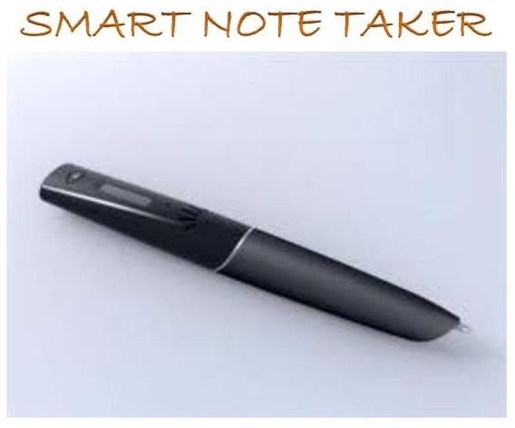

The Smart Pen is one of several data entry options available from our integrated clinical trials system. Health Decisions takes the best technology and applies it to your clinical trials. That's how it should be done. Knowing what is going on in the field is limited by how quickly data are collected and transmitted. The Smart Pen system, a data entry option of Health Decisions’ integrated Clinical trials Management System, establishes a new standard for ease quickly data are collected and transmitted. The Smart Pen system, a data entry option of Health Decisions’ integrated Clinical trials Management System, establishes a new standard for ease of use in sites and speed of data transmission.

It recognize up to 22 Languages : English – Canada , English - GB, English US ,Germa , Simplified Chinese, Traditional Chinese, Korean Danish, Spanish, Spanish - Mexico, Finnish, French , French-Canada, Greez, Italian, Japanese, Dutch, Norwegian, Portuguese , Portuguese- Brazil, Russian, Swedish. Many different formats are used to structure information and make it easier to find and to understand later. The format of the initial record may often be informal and/or unstructured. One common format for such notes is short hand, which can allow large amounts of information to be put on paper very quickly. Historically, note-taking was an analog process, written in notebooks, or other paper methods like Post-It notes. In the digital age, use of computers tablet PCs and personal digital assistant (PDAs) is common.

The note taker usually has to work fast, and different note-taking styles and techniques try to make the best use of time. The average rate of speech is 2–3 words per second (which is 120-180 words per minute), but the average handwriting speed as only 0.2–0.3 words per second (which is 12-18 words per minute). Regardless of the medium, note-taking can be broadly divided into linear and nonlinear methods, which can be combined. Regardless of the system used, it can be best to focus on writing down the most important information first.

* 1. **HISTORY OVERVIEW**

Note-taking has been an important part of human history and scientific development. The Ancient Greeks developed hypomnema, personal records on important subjects. In the Renaissance and early modern period, students learned to take notes in schools, academies and universities, often producing beautiful volumes that served as reference works after they finished their studies. In pre-digital times, people used many kinds of notebooks, including common place book, accounting waste book, and marginalia.

Philosopher John Locke developed and published a popular indexing system. which served as a model for commonplace books and inspired at least ten different published editions of commonplace book templates in Europe and the Americas as well as Bell’s Common-Place Book, Form’d Gernerally upon the Principles Recommrnded and Practised by Mr Locke(London,1170). More modern versions of note-taking systems include the Zettelkasten system used by Nikias Luhmann. One of the smart note taker is LIVESCRIBE SMART PEN, invented by Jim Margraff in Oakland. With the help of the smart note taker handwritten notes will be instantly converted into editable text. It is good and helpful for blinds that think and write freely.

In order to meet the technical requirements of the product we need Operating System Like Windows or Linux in order to implement software part of the project, Displacement Sensors to recognize the displacement of the pen in three dimensions, parallel cable to communicate with computer, software to solve the displacement data and finds the individual coordinate displacements in three axes and transform the data into text format, analog to digital converter to process analog displacement data and convert them into digital format, switch to control the pen and Rechargeable battery.

PC Notes Taker is the world's first device that captures natural handwriting on any surface onto a PC in real time. Based on a revolutionary electronic pen, PC Notes Taker displays the user's handwritten notes, memos or drawings on the computer, and stores the image for future use. PC Notes Taker is ideal for markets where handwritten input is essential, such as health, educational and financial sectors. Supplied with user friendly software, PC Notes Taker is compatible with PCs and notebooks. Adds Handwriting Input to any Computer PC Notes Taker is the world's first device that captures natural handwriting on any surface onto a PC in real time.

Based on a evolutionary electronic pen, PC Notes Taker displays the user’s handwritten notes, memos or drawings on the computer, and stores the image for future use. PC Notes Taker is ideal for markets where handwritten input is essential, such as health, educational and financial sectors. Supplied with user-friendly software, PC Notes Taker is compatible with PCs and notebooks.

* 1. **TECHNICAL DEFINITION OF THE PRODUCT**

In order to meet the technical requirements of the product we need Operating System Like Windows or Linux in order to implement software part of the project, Displacement Sensors to recognize the displacement of the pen in three dimensions, parallel cable to communicate with computer, software to solve the displacement data and finds the individual coordinate displacements in three axes and transform the data into text format, analog to digital converter to process analog displacement data and convert them into digital format, switch to control the pen and Rechargeable battery.

* Operating System
* Software program to convert data into text or string format Displacement Sensor
* Parallel cable
* Analog to digital converter
* Switch · Rechargeable battery

There will be an additional features of the product which will monitor the notes, which were taken before, on the application program used in the computer. Then, the sensed figures that were drawn onto the air will be recognized and by the help of the software program we will write, the desired character will be printed in the word document.

* 1. **HOW TO USE?**
     + Install the driver and application software.
     + Plug-in the USB connector of into your computer's available USB port.
     + After successfully installing driver software begin testing by moving it around. When navigating, have it in an upright position for best accuracy and ease.
     + Switch between Mouse mode and Pen mode.

# SYSTEM OVERVIEW

* 1. **CONSTRUCTION**

Since, JAVA applet is suitable for both the drawings and strings, all these applications can be put together by developing a single JAVA applet program. The java code that we will develop will also be be installed on the pen so that the processor in the pen will and and type the able to draw desired text on the display panel.

* 1. **Applet**

Applet is a function of java which for example, is a kind of container (file) which contains a set of programs made in java. Java is a high level language. It is widely used in making various application Based on java. It is one of the best features of java. The various strings, drawings etc will be made using a class file and this file will not be a single file. It will be a set of files linked together in a single.

* 1. **Database**

The system installed in the pen will consist of a database which will help the processor to recognize various words made visually in the air. Each word written in the air will resemble to a word in the database and the word present in the database will be printed. This will remain the basic principle of the working of a smart note taker.

* 1. **Working**

Smart note taker will be simple but powerful. The product will be able to sense 3D shapes and motions that user tries to draw. The sensed information will be processed and transferred to the memory chip and then will be monitored on the display device. The drawn shape then can be broadcasted to the network or sent to a mobile device. There will be an additional feature of the product that will monitor the notes, which were taken before, on the application program used in the computer. This application program can be a word document or an image file. Then, the sensed that were drawn into the air will be recognized and with the help of the software program software we will write the desired character will be printed in the word document. If the application program is a paint related program, then the most similar shape will be chosen by the program and then will be printed on screen.

The Smart Pen optically records pen movements over a grid – enhanced paper CRF. Its mini camera captures stylus activity 100 times per second. Pen storage capacity can range to over 250 CRF pages. When docked, the pen initiates a connection to the PC. After a start prompt and the username and password are entered, data from the pen are automatically sent over the Internet to a secure Health Decisions server. The Smart Pen is one of several data entry options available from our integrated clinical trials system. This gadget is basic, however extraordinary. This gadget can sense the three dimensional images and moments drawn by the user/clients. These detected data or information is handled and moved to memory chip through which these three dimensional shapes will be examined on display devices. The characteristic of this product that it can keep track on the notes, which were taken before on an application program used in computers. This application program can be a word document or image file. The sensed shape that is drawn in the air will be recognized and the character that is wanted can be written with the assistance of software program and later can be imprinted on the word document.

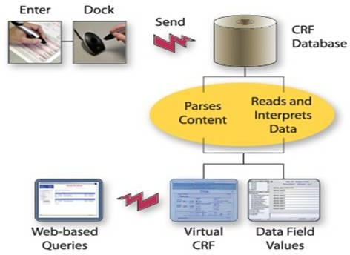

**INTERIOR STRUCTURE OF SMART NOTE TAKER**

* + - **CAMERA**

We can embed a camera in our pen to save our time. With help of camera we can click pictures of notes and that can be saved in pen’s memory chip.

* + - **SENSORS**

How can we be so sure that are writing each and every letter or alphabet correctly in air? To make sure we are writing correctly we can embed error detection sensors in it. It can detect wrong letters or alphabets and thus we can make no mistakes in our notes.

* + - **BATTERY**

We can have more powerful battery in this pen so that it can work for longer period of time. Although it has rechargeable battery but battery it should not be that weak that it gets dead by writing small amount of notes. And in order to save battery we can have one additional mode in our pen which can save our battery. Like we have battery saver option in our laptops and smart phones, so we can have this similar option in our pen too.

* + - **STORAGE**

We can increase the capacity of storing notes in pen. This can be done by embedding memory chip of greater storing capacity. We can store more notes in our pen if we have memory chip of more storage capacity.

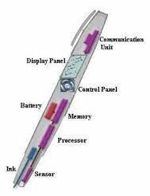

# TECHNIQUES USED IN SNT

**DISPLAY TECHNOLOGY**

Technology used in Smart Note Taker for display is Kopin Corp’s Cyber Display technology. Cyber Display is a¼ inch diagonal LCD that uses circuitry built on a silicon wafer, then removed and mounted to glass. The displays are integrated to miniature monitors using its own backlighting, optics, ICS and packaging.

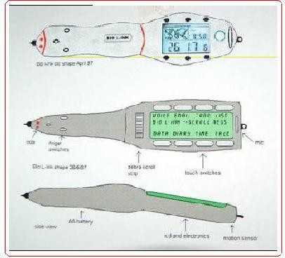

**HAND WRITING RECOGNITION**

Accelerometers measure hand movement in 2 or 3 planes. On board DSP converts to ASCII characters for pen applications. Write on paper, flat surface, and vertical wall or in air. Single character recognition on pen Smart Note Taker works by measuring the pen's movements and matching them to the movements.

That produce letters and words programmed into its memory. It's similar to the way a microphone detects sound. Consistency of handwriting, rather than neatness, is the only condition for accuracy.

There are 2 techniques used for this purpose:

1. Accelerometer technology
2. Handwriting recognition software

**Accelerometer Technology**

This technology uses a device called Accelerometer which is used for measuring motion. A tiny accelerometer in a pen could be used to detect the stops and starts, arcs and loops of handwriting, and transmit this information to a small microprocessor that would make sense of it as text. There's also the possibility of viewing a full page of text through a special monocular magnified "virtual" screen that could be built into the end of the pen. Invisible writing in air is achieved through this unique technology called accelerometer that monitors hand movements and can also be used as a ‘virtual hinge’ to scroll around the small screen on the pen and detect left or right- handed use.

It records movement by using the earth's gravity system, whether you write on paper or in the air. Hence it is independent of surface used. Movements are stored within the Smart Note Taker. This information is transmitted on to a small microprocessor that would make sense of it as a text displayed on the sleek built in screen.

There are 2 types of accelerometer

* 1. **Two Axes Accelerometer:**

This accelerometer measures acceleration in two axes. An Example for Two Axes Accelerometer is ADXL202 Accelerometer.

* 1. **Three Axes Accelerometer:**

This accelerometer measures acceleration in three axes. An Example for Three Axes Accelerometer is Tonics +/- 2g accelerometer. An accelerometer is a device that measures proper acceleration. This is not necessarily the same as the coordinate acceleration (change of velocity of the device in space), but is rather the type of acceleration associated with the phenomenon of weight experienced by a test mass that resides in the frame of reference of the accelerometer device.

# APPLICATIONS

* Write a letter or take note. It converts your handwriting into text. Any handwriting is recognized 99.9% accurately. Write in cursive or print, even a combination!
* Tired of Printing, then signing, then faxes documents just to add a signature? You can input your signature on any document.
* Mark and highlight a document for changes in any application. Add handwritten captions on photographs. Write a note right on a web page as if you were marking a newspaper. Then save and send.
* Make a point of importance on any Presentation.
* Art / Graphics Pen Mouse - compatible with all graphics software for both PC and Mac.
* With the help of smart note taker handwritten notes will be instantly converted into editable text.
* Another place, where this product can play important role is where two people talk on the phone. The subscribers are apart from each other while their talk and they may want to use figures or text to understand themselves better
* .Can be use by teachers directly and indirectly by students, too
* Smart note taker is reliable and powerful.
* It is helpful for blinds that think and write freely.
  + 1. **PRESENT AND FUTURE OF SNT**

Companies had succeeded to make similar products and put them in the market. Putting a newly invented, innovative product in the market is not easy. The prices in the market must be well observed for similar products. The prices of 2-D digital pens are about 50 dollars to 90 dollars. So the price of smart note taker will be high. But this disadvantage definitely is eliminated in near future. Future models could receive e-mails and pager messages via a wireless messaging system and could use digital signature recognition for security purposes. Working on improving the handwriting recognition software and expects it to understand cursive.

In the current market there are many similar product that can convert handwritten documents into digital type documents. In these product optical sensor are widely used to perceive the motion. The price of smart note taker is high but it definitely will eliminated in future. The system will try to improve a pen, which helps people get rid of typing problems on computer by the technology, which converts your handwriting to text format on your PC.

Writing on Air is a superb anthology. Since smart note taker have several advantages and features still there is a need of some improvement. China is doing the work to add some additional features i.e to add a camera and memory locator which will directly show the status of free memory making the user more comfortable. In order to utilitize the time and to take more attention of students smart note taker is a great solution, which transfers the notes of the teacher on the board to software directly. It optimizes efficiency of time that is used during the lecturing and it is desirable for the education.

# ADVANTAGES

* Can be used as standard pen and can carry anywhere without stressing mind to carry it.
* With the help of smart note taker we can write notes on any surface even in air. That is we can write notes any time without using a paper
* It is used along with paint and JAVA graphics so we can say this product is compatible with all graphics software.
* Light weighted and easily portable -on phone talks or for instructor.
* Useful for any person, any institute.
* Smart note taker is reliable and powerful.
* It is helpful for blinds that think and write freely.
* Easy-to-use wireless connection.

# DISADVANTAGES

* The cost of this product is high when compared with other products.
* There is no possibility of storing the templates as well as formats other than word documents and graphic files.
* The data from this product cannot be transferred to other device.
* Can’t drag items to other tabs directly.
* Lack of product awareness among the people.

# CONCLUSION

The system will try to improve a pen, which helps people get rid of typing problems on computer by the technology, which converts your handwriting to text format on your PC. However, the technology provides opportunity to write on air, which means it, needs no any item to convert the typing to your computer such as 3D view. Beside this, it can also be used like all other classical pens. Therefore, this device will increase the capacity of noting the texts, lessons and projects you work on. One other fact that appears is similar products generally works in a way that they store the writing by memory systems and direct the data to computer. We will vanish this time lag by using a technology that the data will be sent to PC directly not by stored. It is sure it will be hard to eliminate the other products as our rivals, but our advantage in this market will be the properties of the device, which come to be its high mobility, versatile design and its ideal weight.

The device takes a practical extent since it offers high mobility. This property may seem useless at first side but the high mobility will help the teachers or individuals, who have dynamism as they do their jobs, by giving them opportunity to write anywhere. . On the other hand, the price of innovation will be reasonable for the sectors that can use it effectively in their business or lessons.